Table of Contents

Introduction 2

1. Description 2

2. Technologies used 2

Project Output 3

1. Signing up a new user 3

2. Login 4

3. Adding a train (by admin) 6

4. Updating train details (by admin) 7

5. Adding a trip (by admin) 9

6. Updating trip details (by admin) 10

7. Showing a list of available seats that satisfy a certain criteria 12

8. Booking Trip 13

9. Canceling Trip 18

10. Updating user details 20

3. Make Admin 22

4. Log Out 24

# Introduction

## Description

This project is about a train booking site in which the user can create an account, filter and search through all the available trips to find a suitable one, and then book any number of seats in that trip provided that he has enough money for the trip. There is also an admin account that orchestrates everything by adding, removing, and editing both available trains and trips.

## Technologies used

* HTML
* CSS
* JavaScript
* PHP
* MySQL
* PHPMailer library
* XAMPP to create a localhost

# Project Output

## Signing up a new user

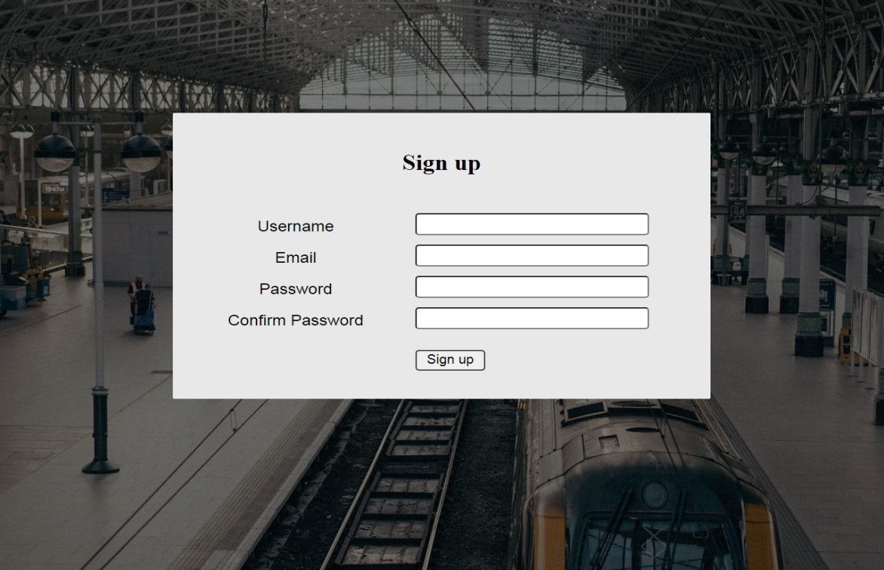

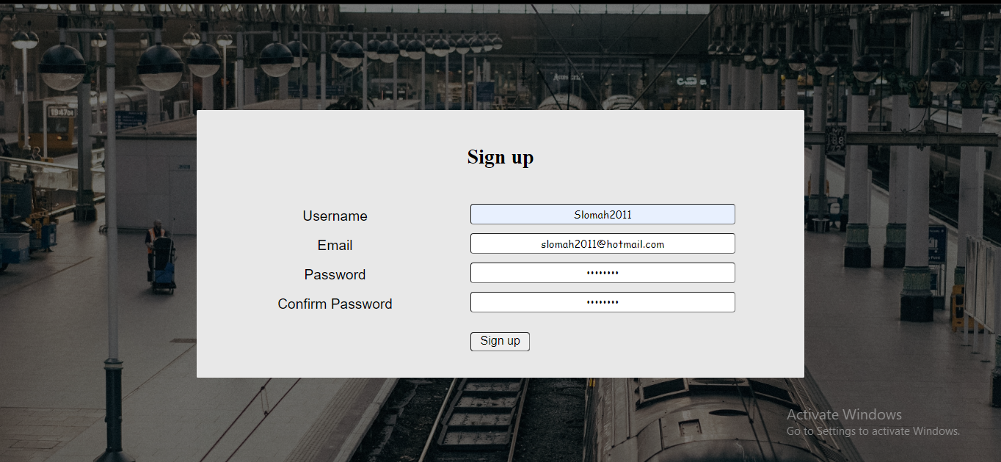

## Login

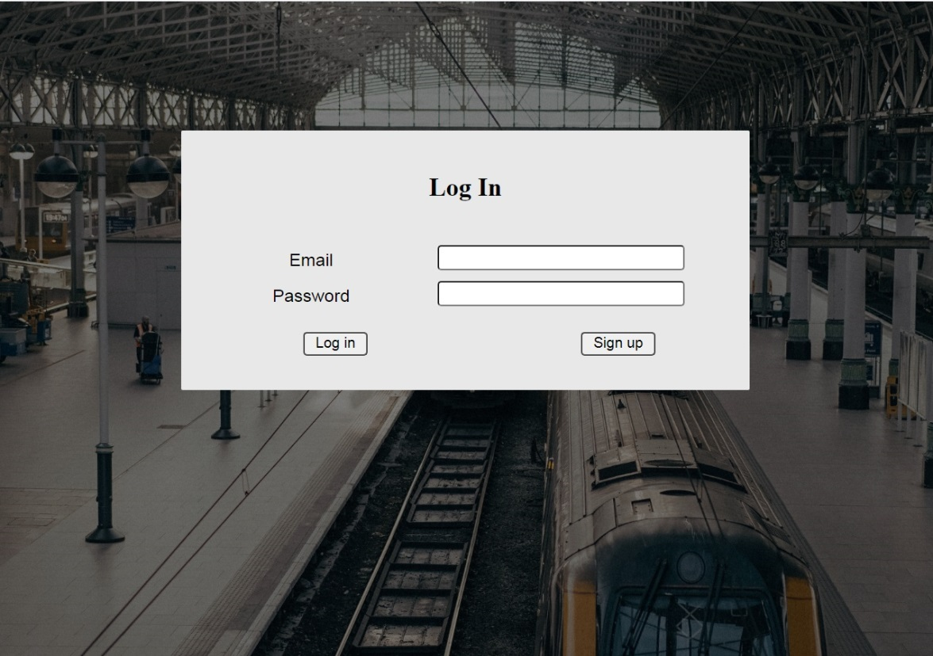

### As Customer

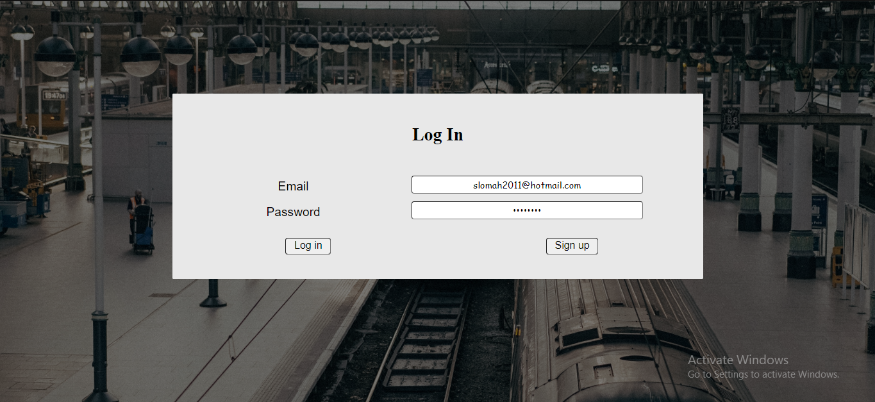

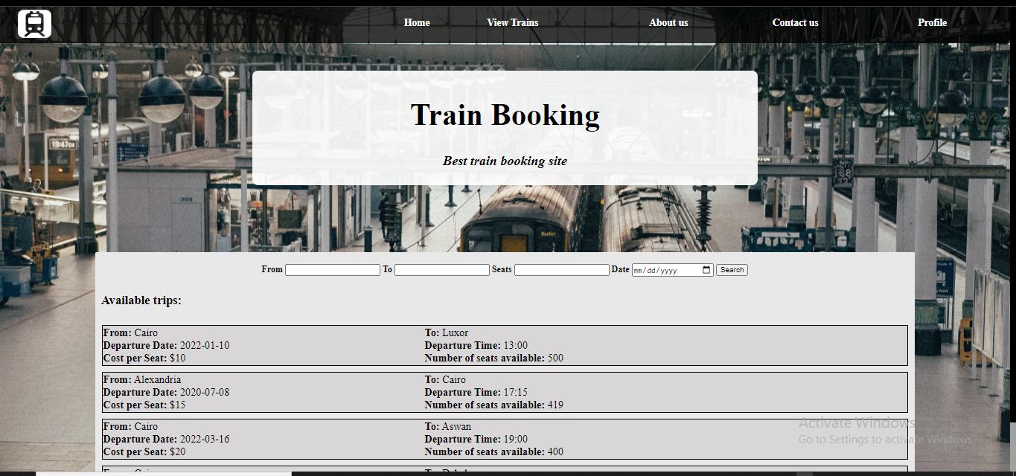

### b. As Admin

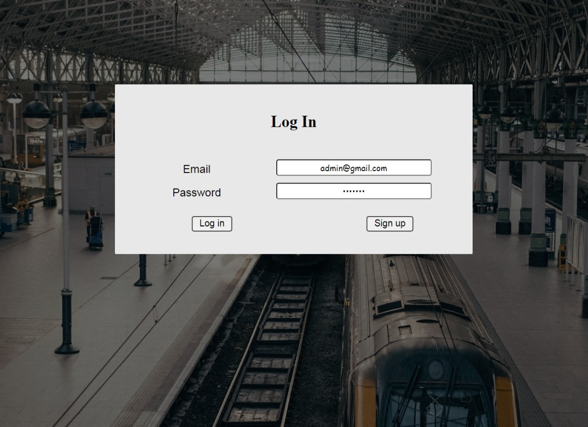



## Adding a train (by admin)

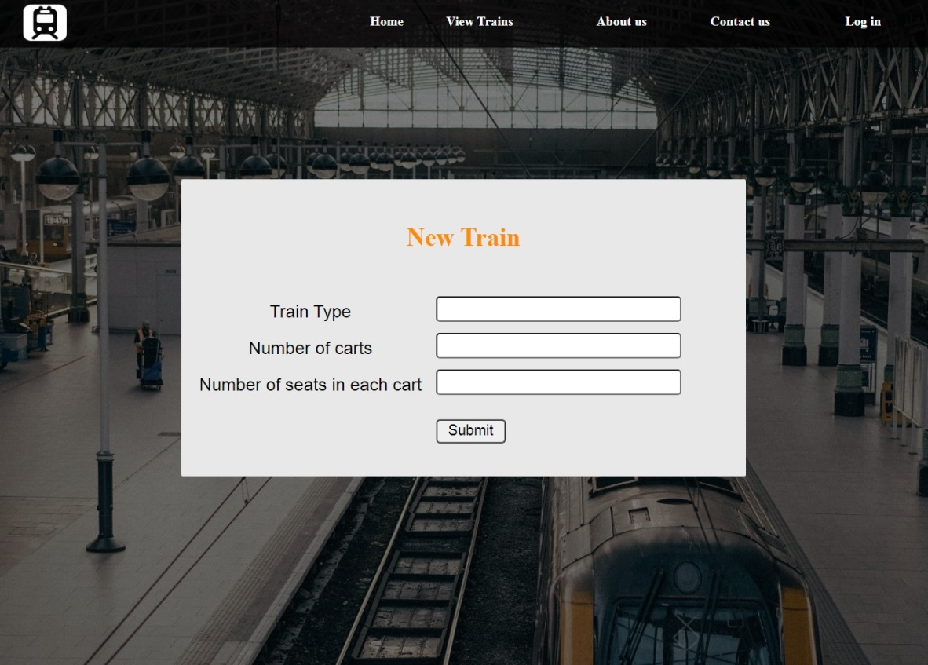

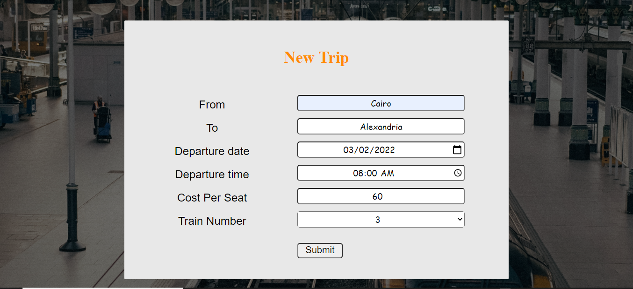

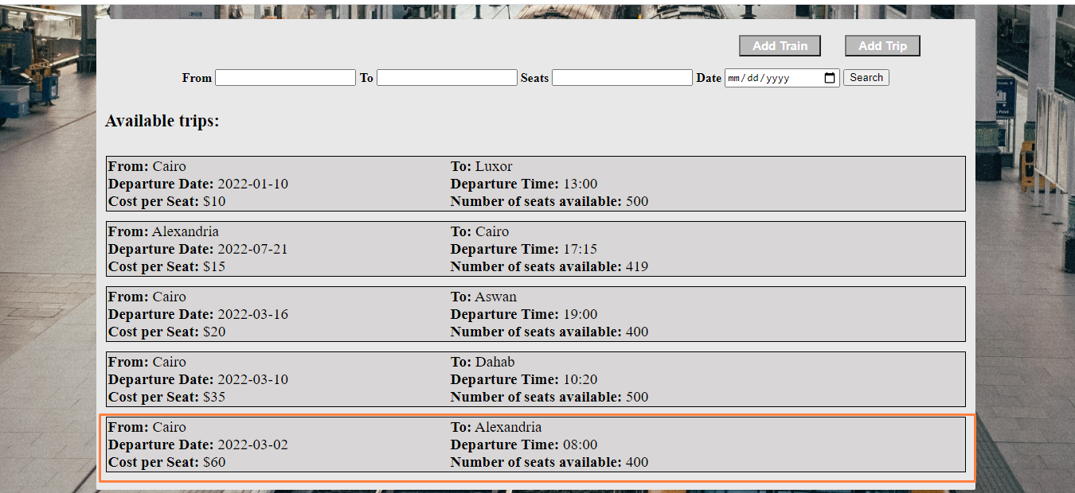

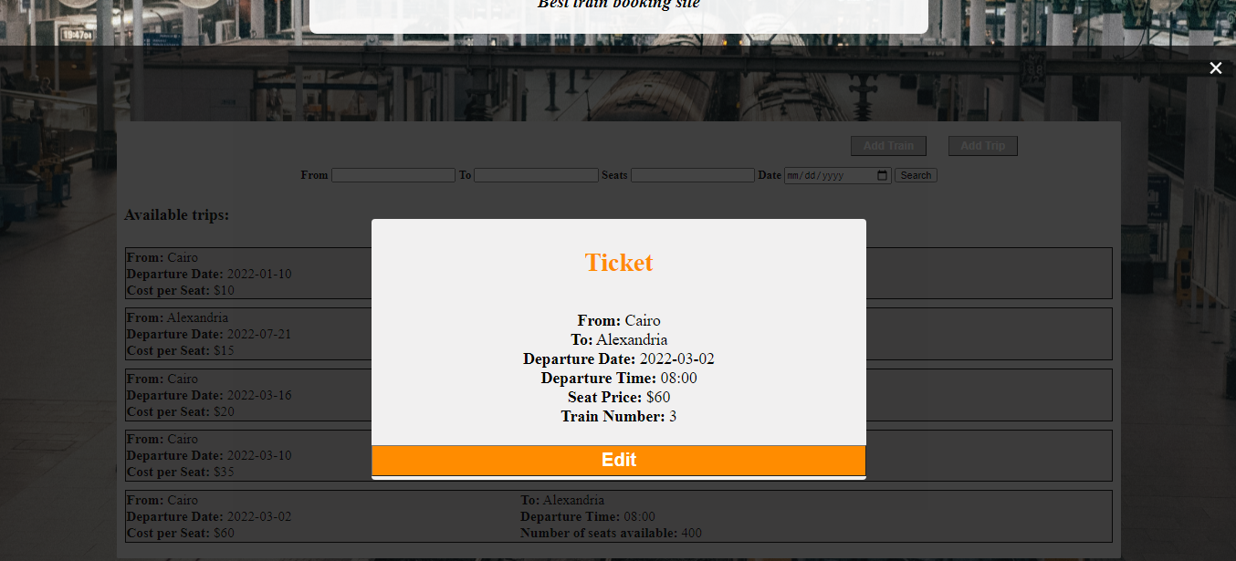

## Updating train details (by admin)

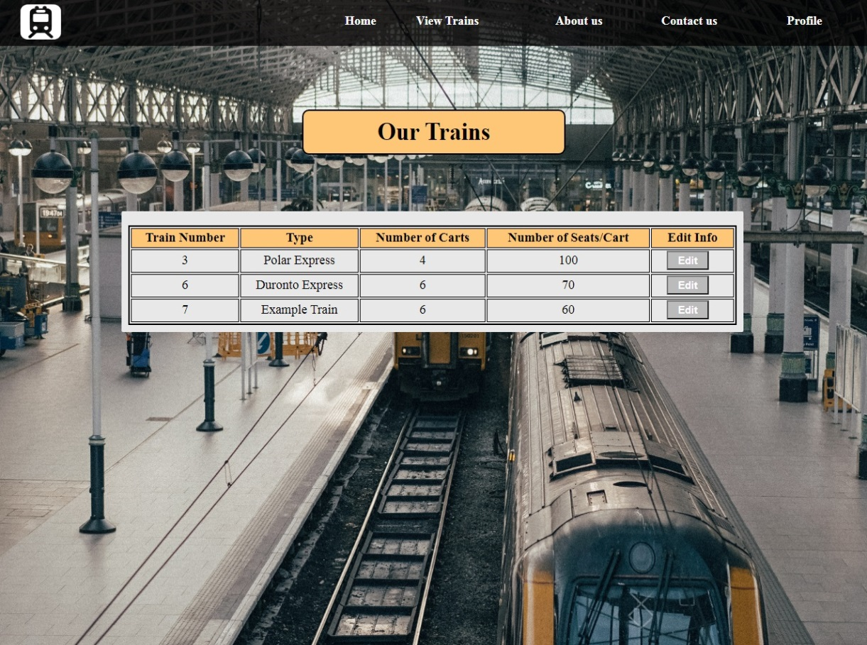

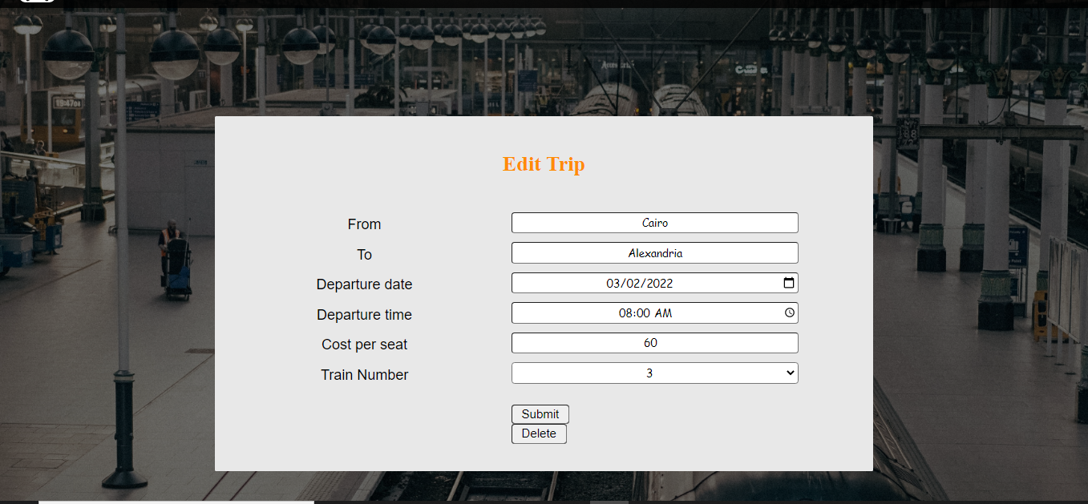

## Adding a trip (by admin)

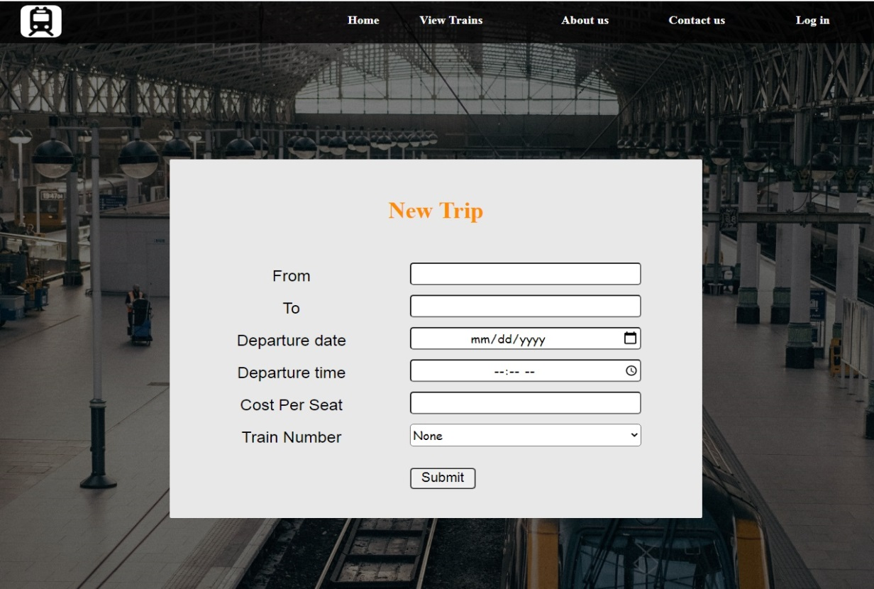

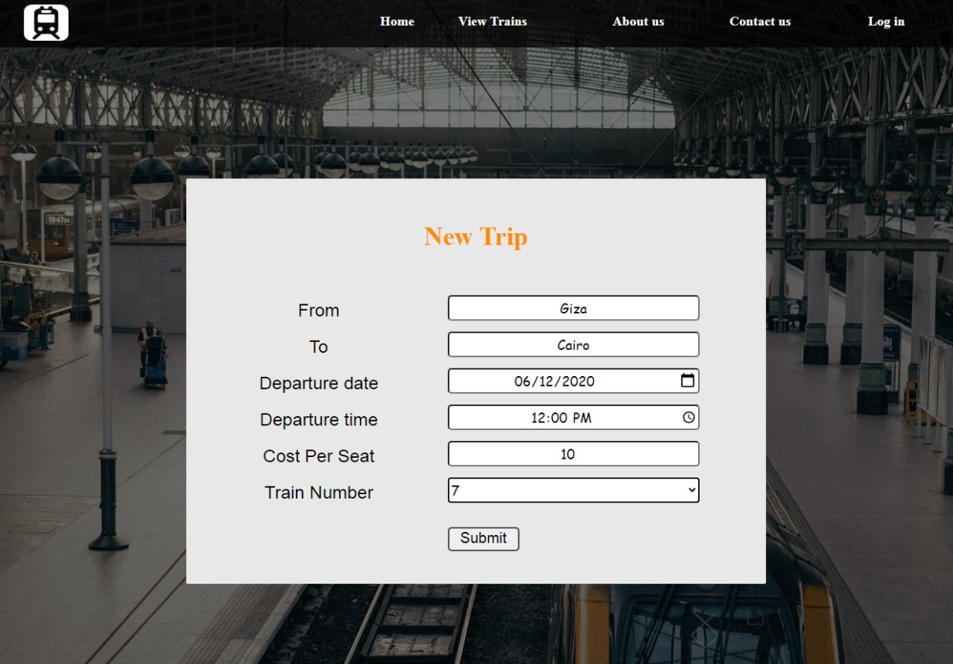

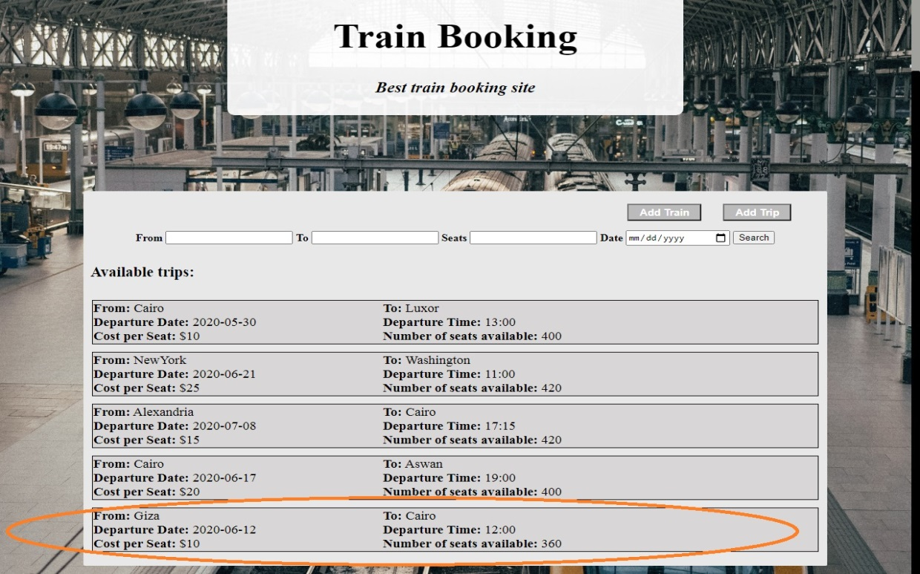

## Updating trip details (by admin)

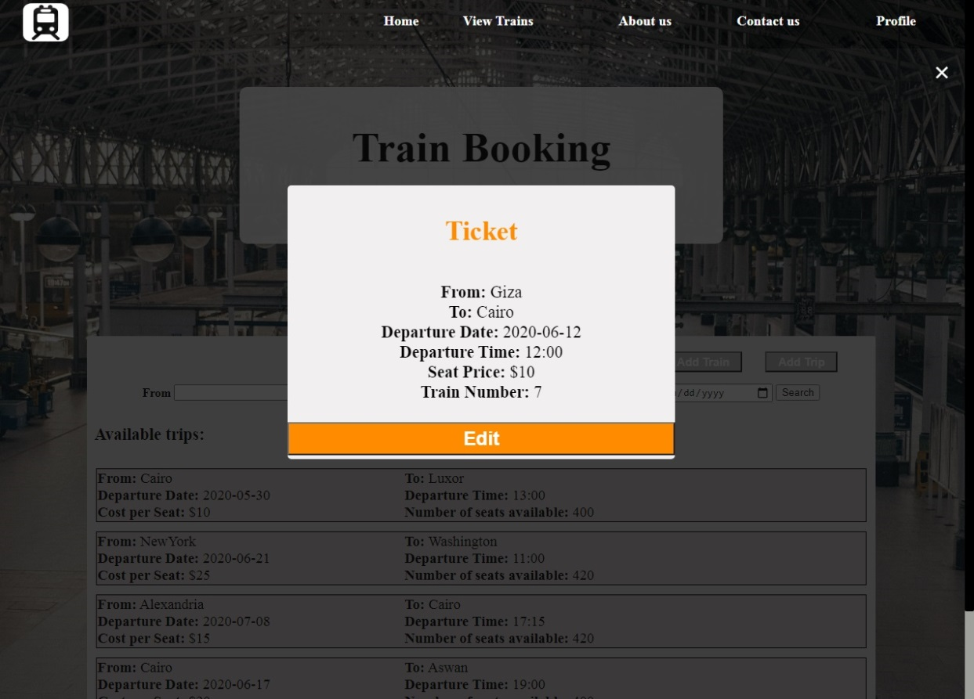



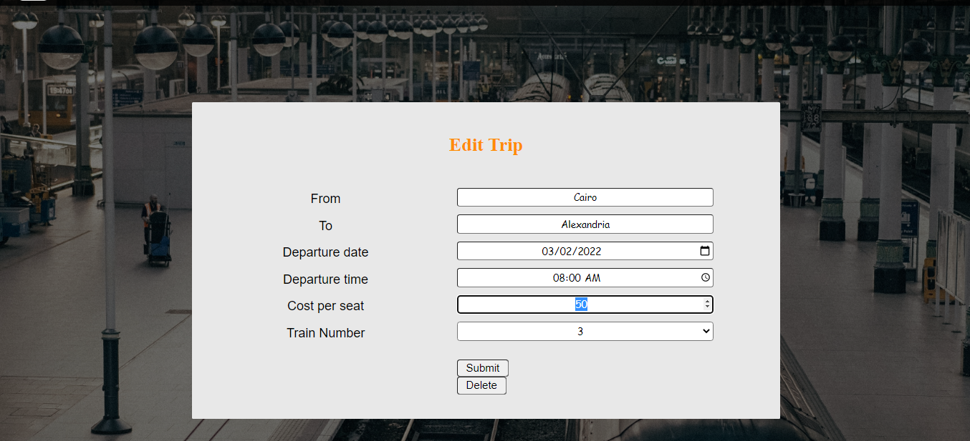

## Showing a list of available seats that satisfy a certain criteria

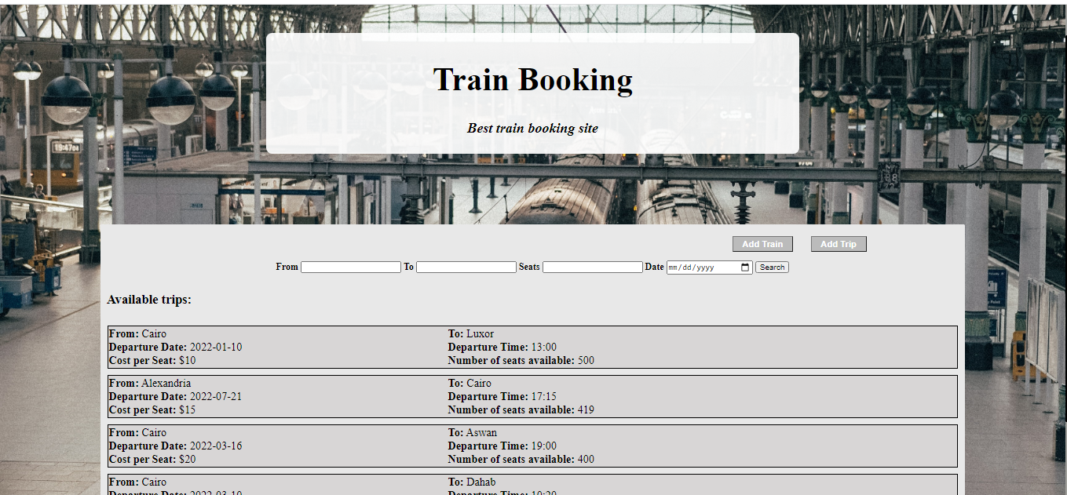

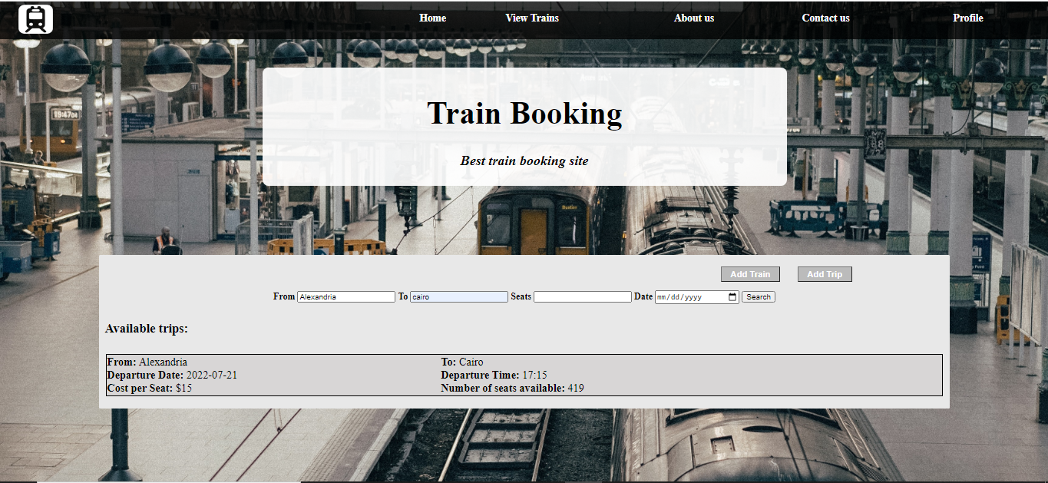

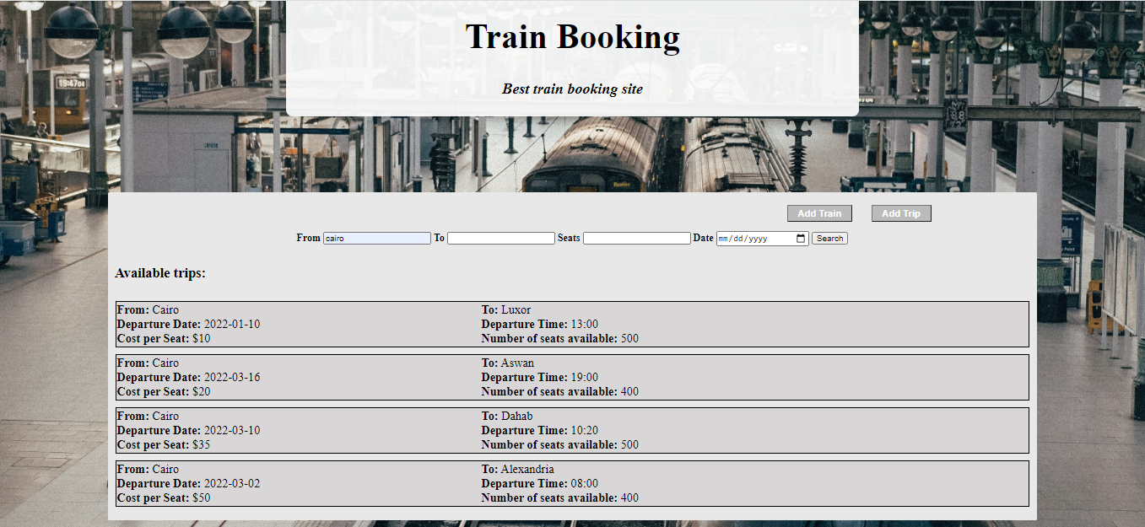

## Booking Trip

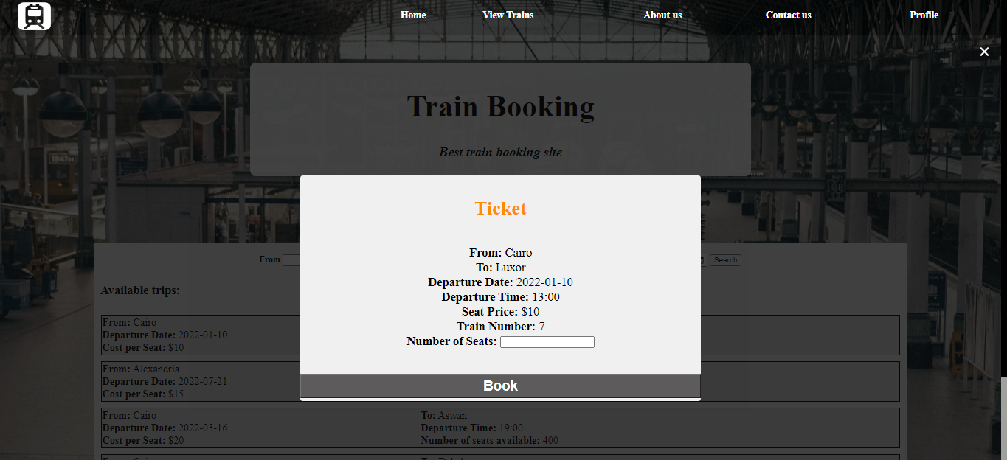

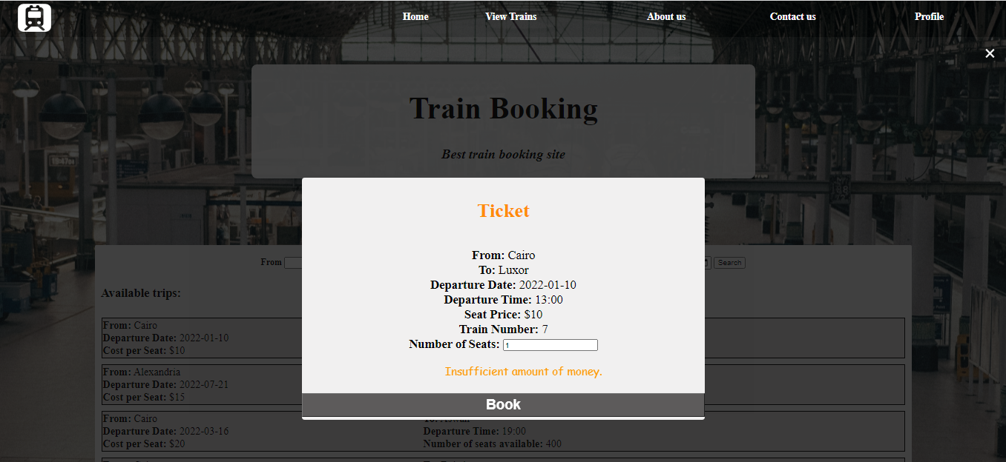

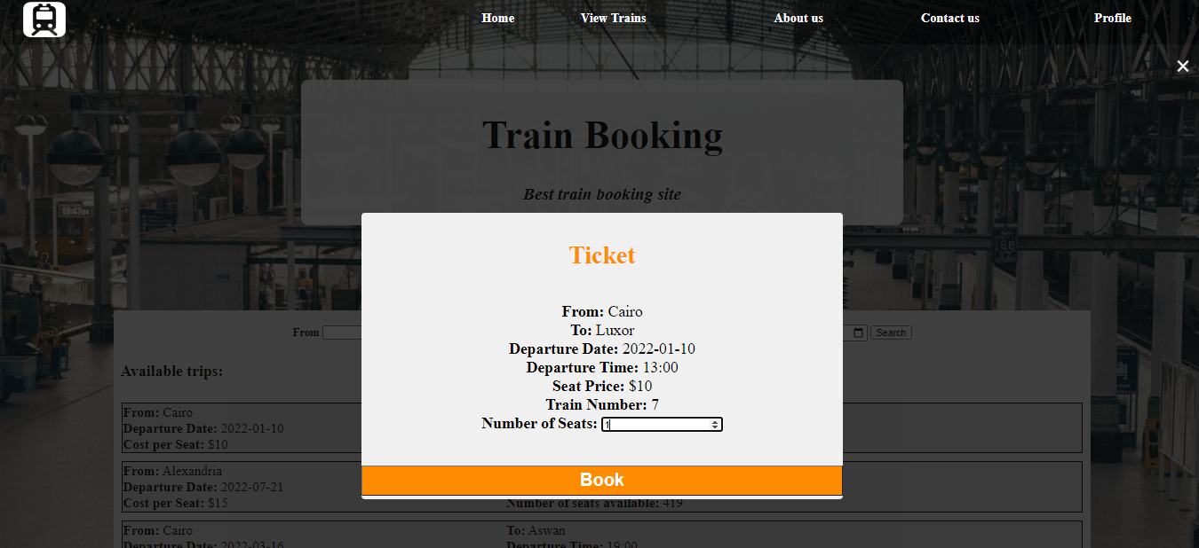

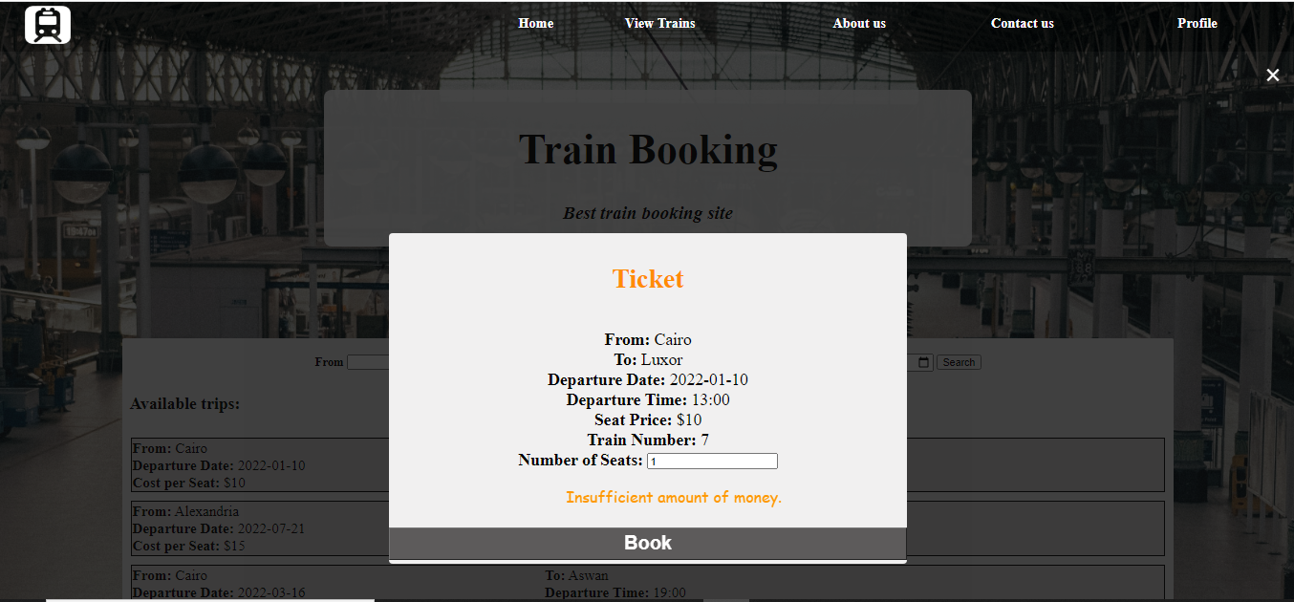

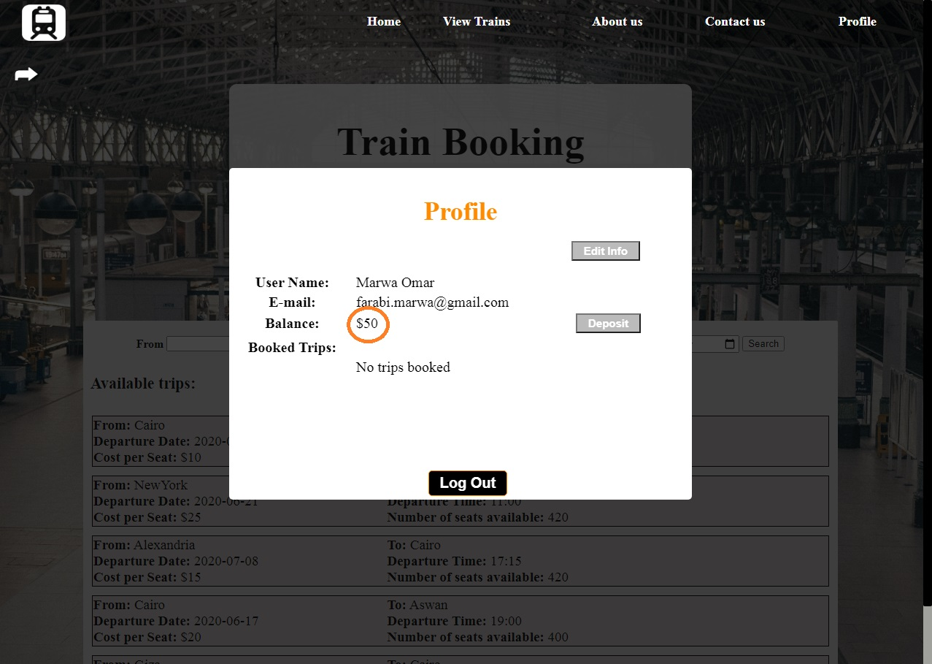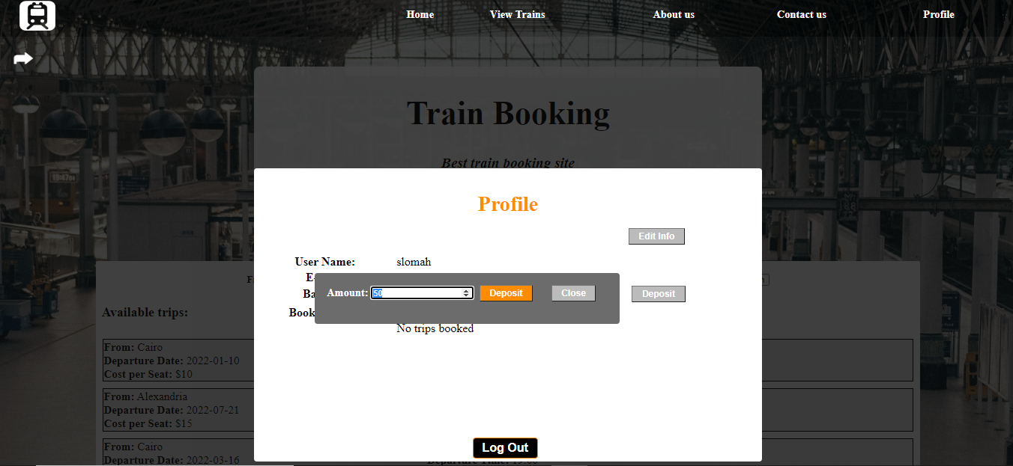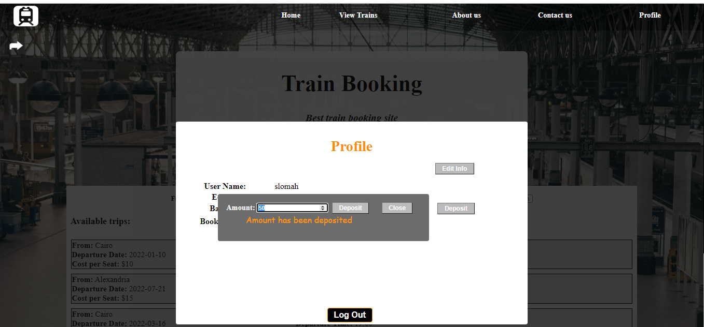

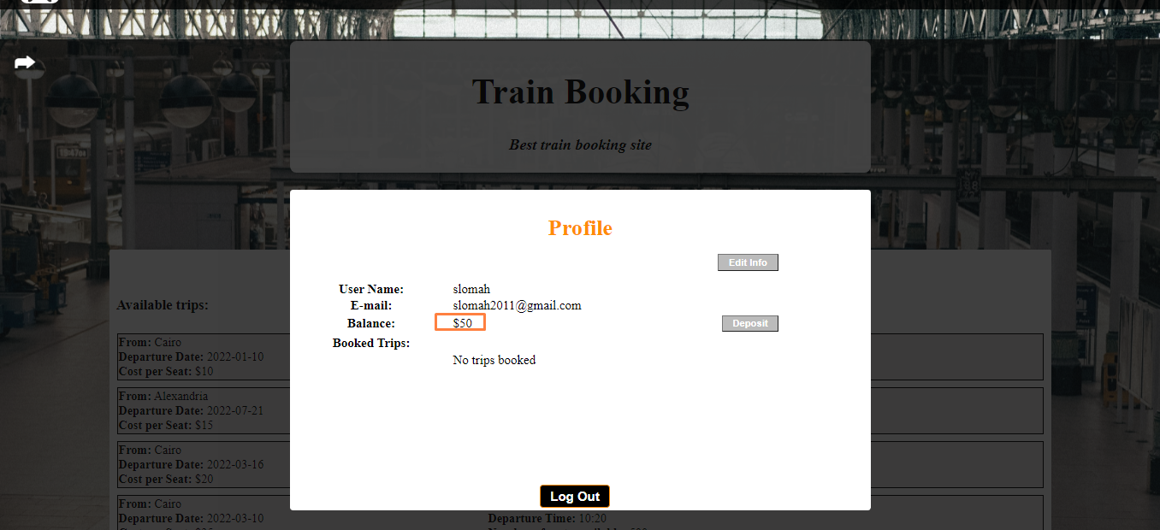

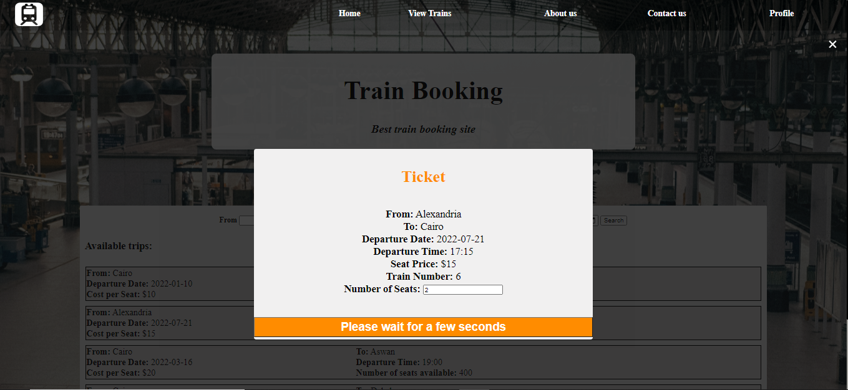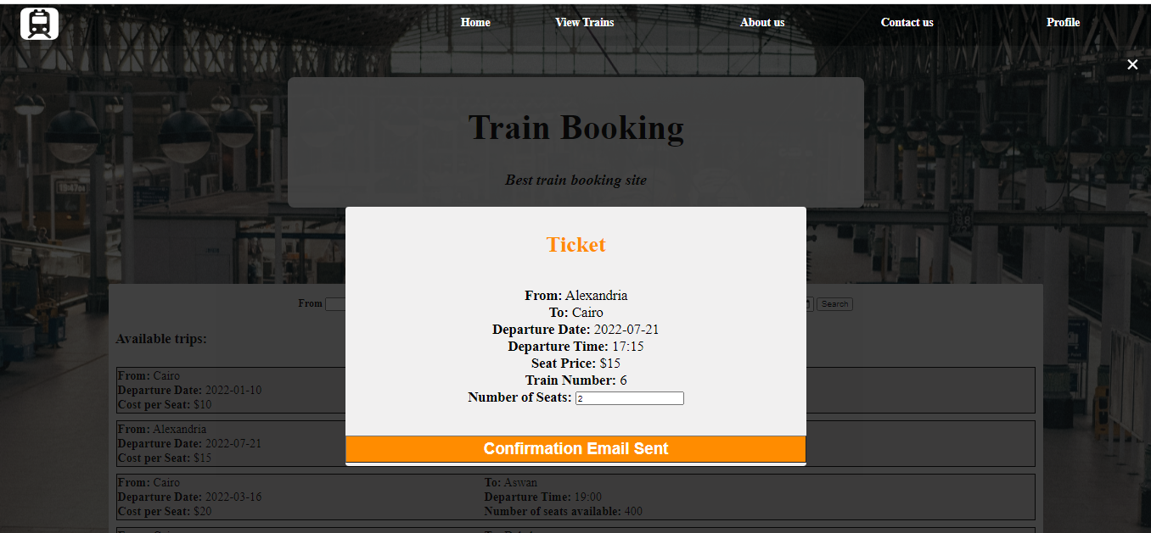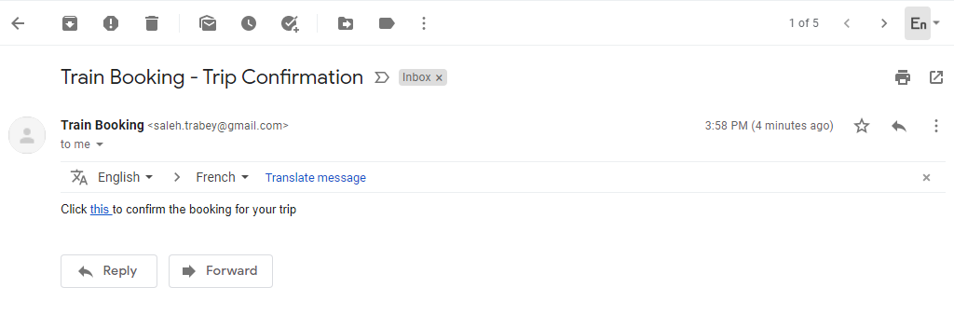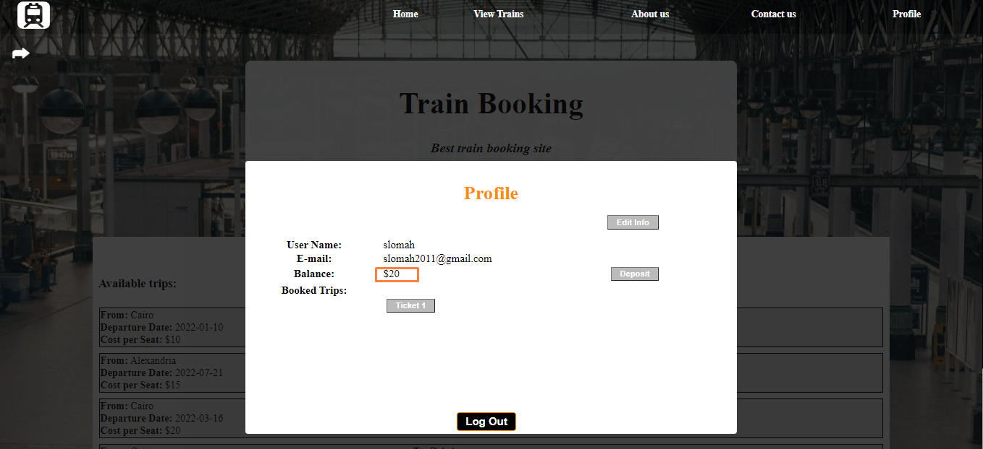

## Canceling Trip

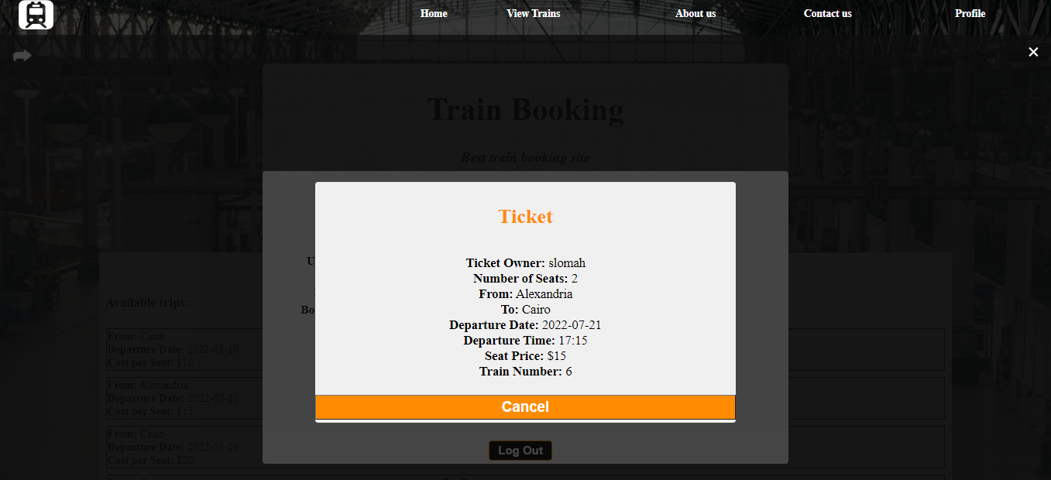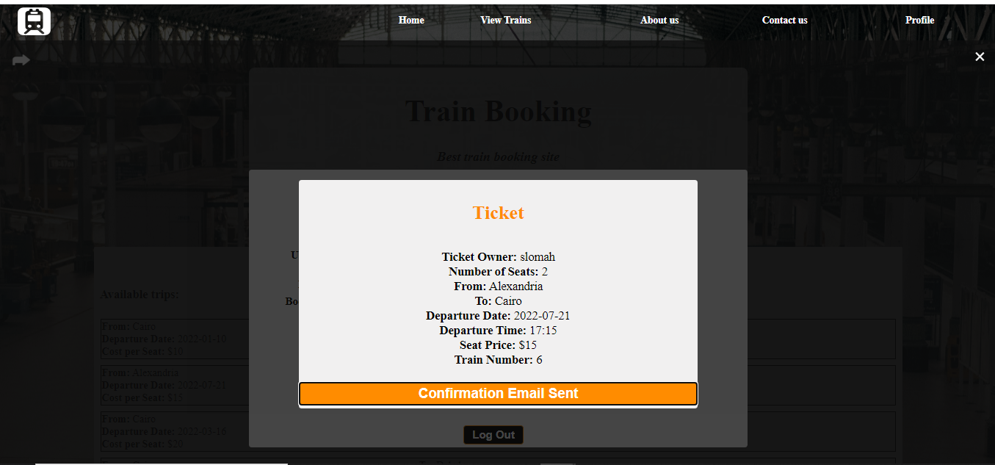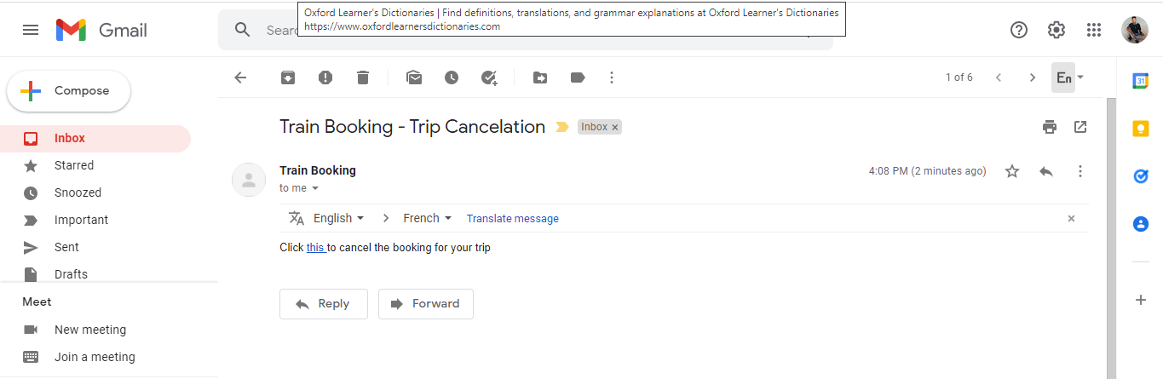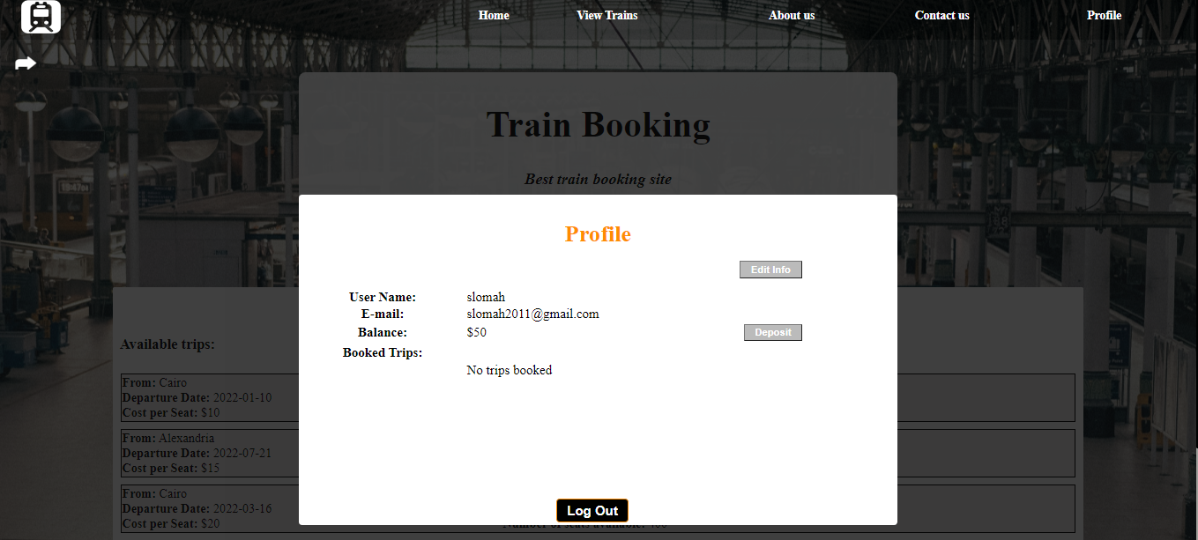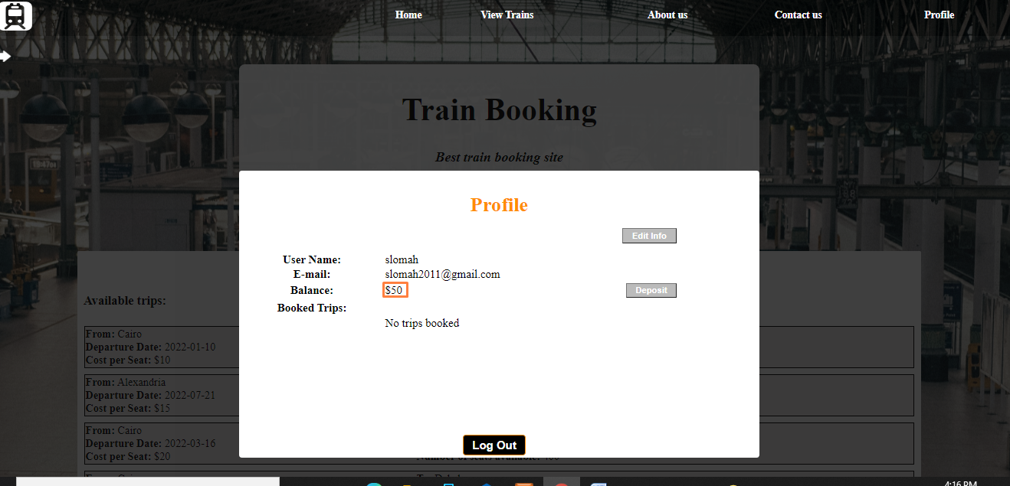

## Updating user details

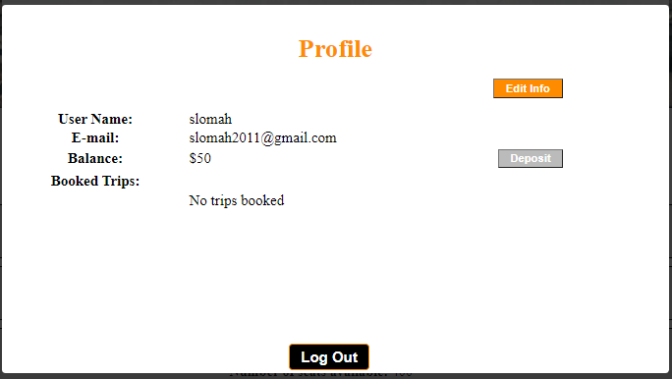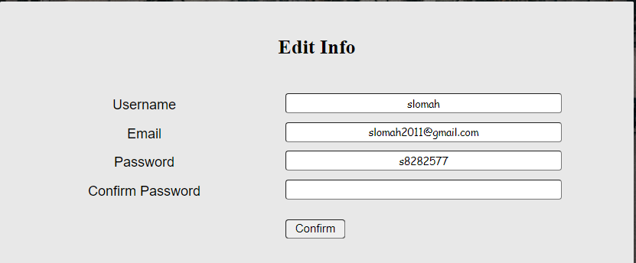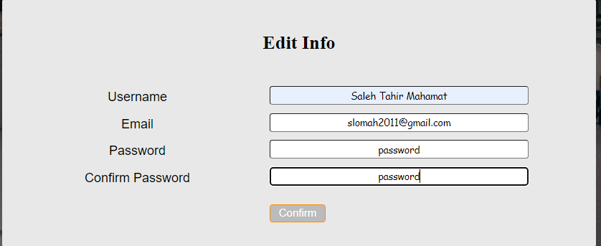

## Make Admin

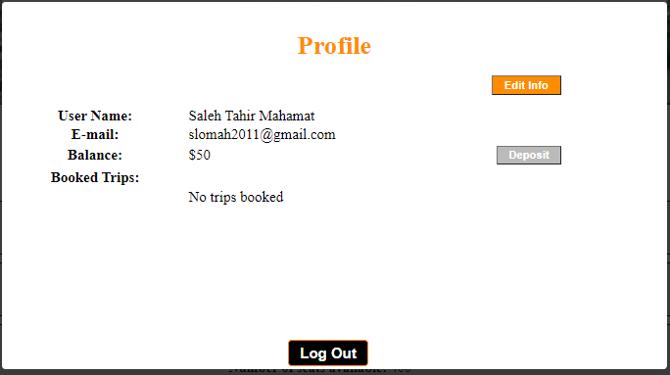

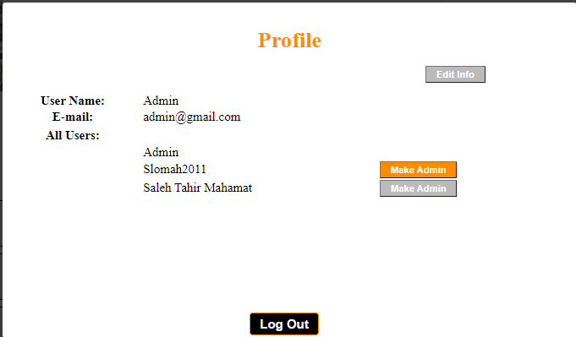

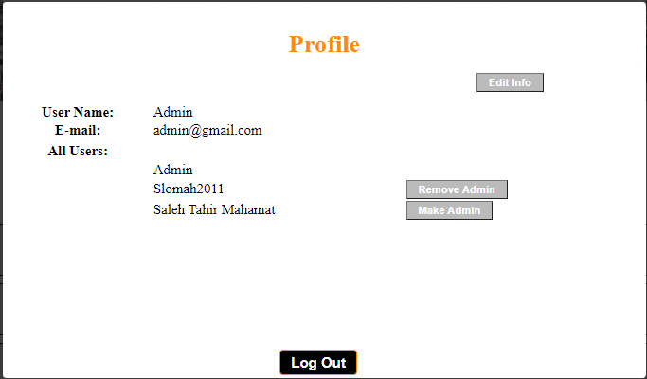

## Log Out

